**QUIZ Life Insurance:**



**.**

**Project**:

**.**

**Finance Crimes**:

Tarun Gupta: Managing Principal Architect (India and Middle East)

Bharat Trivedi: Enterprise Architect (Technology Enablement Group)

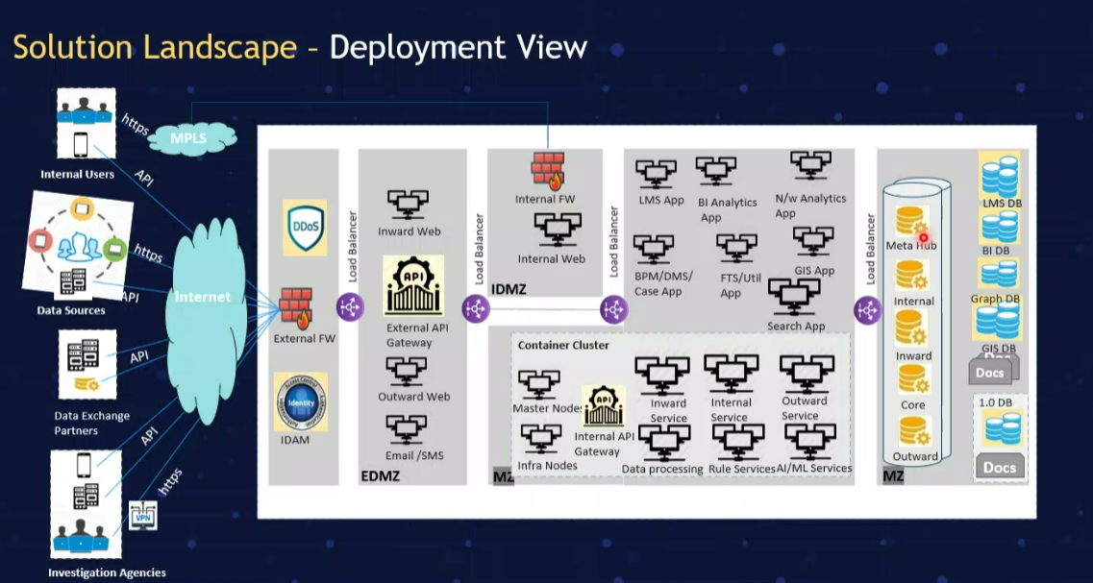

.

**Movies**:

**Finance Fraud**: Jamtara